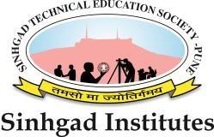
Sinhgad Technical Education Society’s
SINHGAD COLLEGE OF ENGINEERING
Accredited by NAAC with A+ Grade
Affiliated to Savitribai Phule Pune University, Pune

Department of Computer Engineering
410248 & 410256 : Project Work Book
(Guidelines and Log)
Fourth Year Computer Engineering

Year 2025– 2026

Group/Project ID : 37
Team Members : 1. Yashkumar Shamkant Patil
2. Dhanashree Sanjay Lomte
3. Tejas Kailas Patil
4. Aditi Ambadas Khedkar

Project Title : Vidhan: A Gamified Approach to Learning the Indian Constitution with AI Assistance
Project Guide : Prof R.A.Vasmatkar
Area of the Project : Ed-Tech (Educational Technology) &
Civ-Tech (Civic Technology)
Sponsored/In house : Inhouse
Name of External Guide :
Phone No: Email Id:

